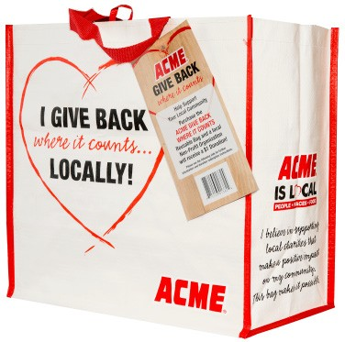
GIVE BACK WHERE IT COUNTS REUSABLE BAG PROGRAM

Launch Day Email

DOWNLOAD IMAGES

SUBJECT: Launch Day for ACME GIVE BACK WHERE IT COUNTS Reusable Bag Program!

Hello,

Today is launch day for the ACME GIVE BACK WHERE IT COUNTS Reusable Bag Program! Starting today and for the entire month of [month of selection], when you purchase a $3.00 GIVE BACK WHERE IT COUNTS Reusable Bag at the ACME located at [location], $1 is donated to [name of organization].

Our goal is to sell [goal of bags bought, e.g., 200] bags, equivalent to $[insert donation equivalent, e.g., $200] raised. We are confident that with the help of our dedicated supporters we can reach this goal.

We strongly encourage you to share this news with family and friends as well!

The GIVE BACK WHERE IT COUNTS Reusable Bags are located on displays around the store and at the checkout. For more information about the program, please visit acme.2givelocal.com.

Thank you for your support,

[Signature]

acme.2givelocal.com

